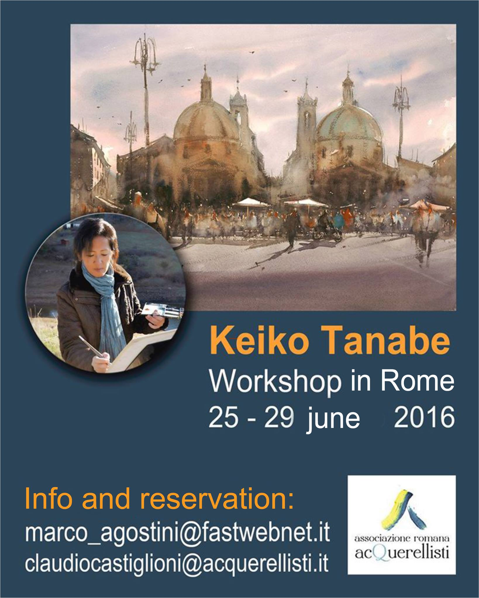

Get ready to enjoy the beauty of Rome while painting en plein air with the great watercolor artist Keiko Tanabe.
KEIKO TANABE WORKSHOP IN ROME ( 06/25 – 29 / 2016 ) GENERAL INFORMATION AND PRELIMINARY PROGRAM
General Information
The workshop includes 5 days of full immersion into the watercolor world. This special workshop is designed for those who would like to gain a better understanding of methods and techniques to make a watercolor painting that is simple yet strong. The aim is to capture the essence of the subject that conveys a certain moods and atmosphere. Keiko will show you how to go from initial inspiration to the simplification process to finish with an expressive painting that is strong in composition and in content. Subject matters include landscapes, cityscapes and waterscapes as represented by the sites chosen in Rome. The start of class focuses on fundamentals, including getting to know our materials and seeing the things with an artist’s eye. Keiko will then guide students through these valuable topics: the importance of tonal value studies, how to do a preliminary drawing, how to edit a complex subject, what makes a good design, understanding a relationship of tonal values and colors and a variety of techniques in paint application and brush handling. Keiko will demonstrate techniques, answer your questions and provide plenty of one – on – one guidance!
Cost of Workshop: € 370,00
Partial participation ( only one or more days ) it is also accepted, in this case the cost will be calculated in proportion to the days of actual participation.
During the collective painting sessions Keiko shall supervise and comment the work on progress of all painting participants.
welcome and farewell buffet ( first and last days ), as well as all packed lunches during workshop activities, are offered by ARA and included in the workshop price.

Preliminary Program

1st day ( 06/25/2016 )
Workshop site: Piazza del Popolo terrace ( ARA headquarters ) Meeting point: 9,30 a.m. steps of S. Maria del Popolo Church Keiko Tanabe demo: from 10,00 ( 10 a.m. ) up to 12,30 p.m. Lunch break: buffet with sandwiches and appetizers from 13,00 ( 1 p.m. ) up to 14,00 ( 2 p. m. ). Collective painting session: en plein air on the terrace or, in case of bad weather, inside the ARA premises from 14,30 (2,30 p.m.) up to 17,00 (5 p.m. )
2nd 3rd and 4th days ( 06/26, 27, 28 /2016 ) Workshop site: still to be selected among the so many amazing location of Rome, just inside the heart of art history. Demo, lunch ( packed lunches ) and collective painting session as above
5th day ( 06/29/2016 ) Workshop site: ARA headquarters main hall, Piazza del Popolo Meeting point: 9,30 a.m. steps of S. Maria del Popolo Church. Keiko Tanabe demo: from 10,00 up to 12,30 p.m. ( members of ARA willing to attend the demo are also invited ). Lunch break: snack lunch and refreshment within the same area from 13,00 ( 1 p.m.) up to 14,30 ( 2,30 p. m. ). Farewell greetings by ARA and by Keiko Tanabe: 15,00 ( 3 p.m.) End of workshop: 17,00 ( 5 p.m. )

For info and reservation please contact:
Marco Agostini marco_agostini@fstwebnet.it
Claudio Castiglioni claudiocastiglioni@acquerellisti.it

